# Exercises: Introduction to Hibernate

This exercise is part of the [“Databases Frameworks” course @ SoftUni](https://softuni.bg/trainings/1635/databases-frameworks-hibernate-and-spring-data-june-2017).

## SoftUni Database

Use the **provided skeleton** to create **soft_uni** database.

1. Change the **port**, **username** and **password** accordingly to your settings.

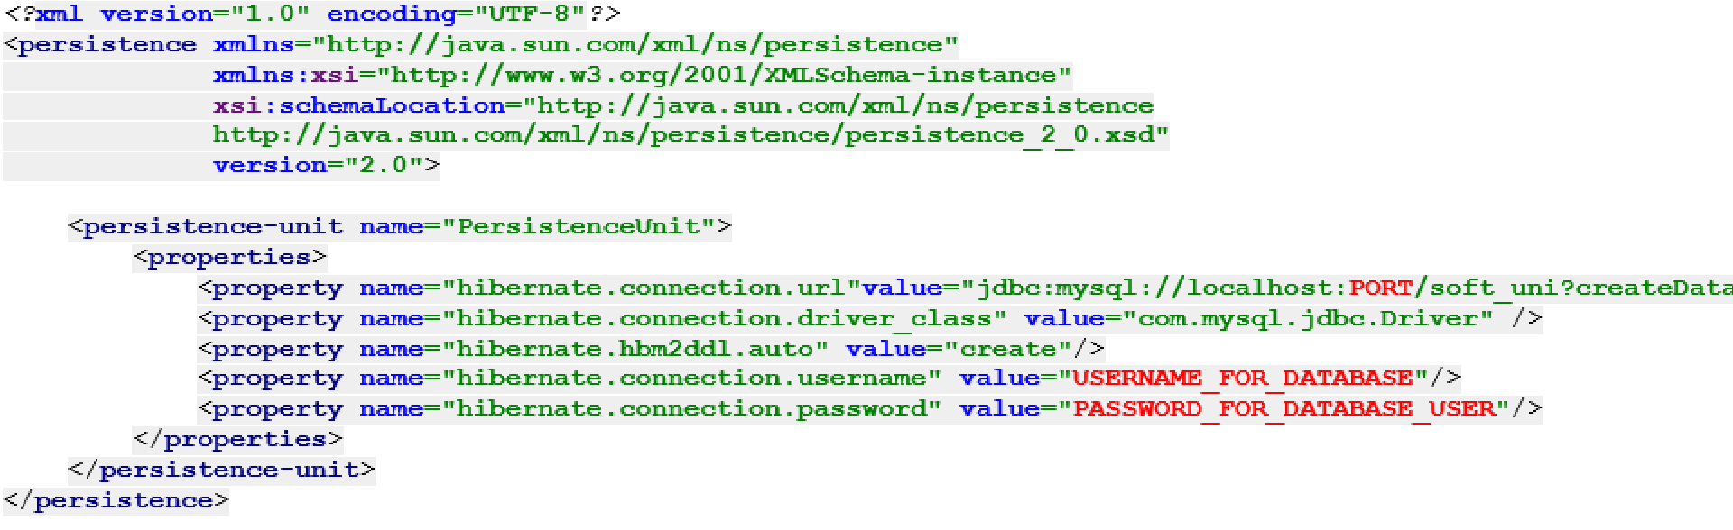

1. **Create** EntiryManagerFactory and **run** your program.

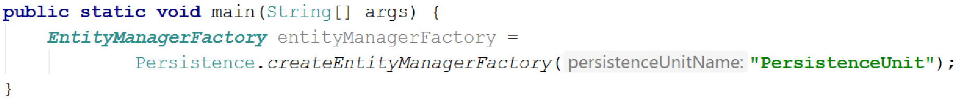

1. After you create the database, change **hibernate.hbm2ddl.auto** property to “**update**”.



1. Fill the database into HeidiSQL by **executing** the provided **.sql** script.

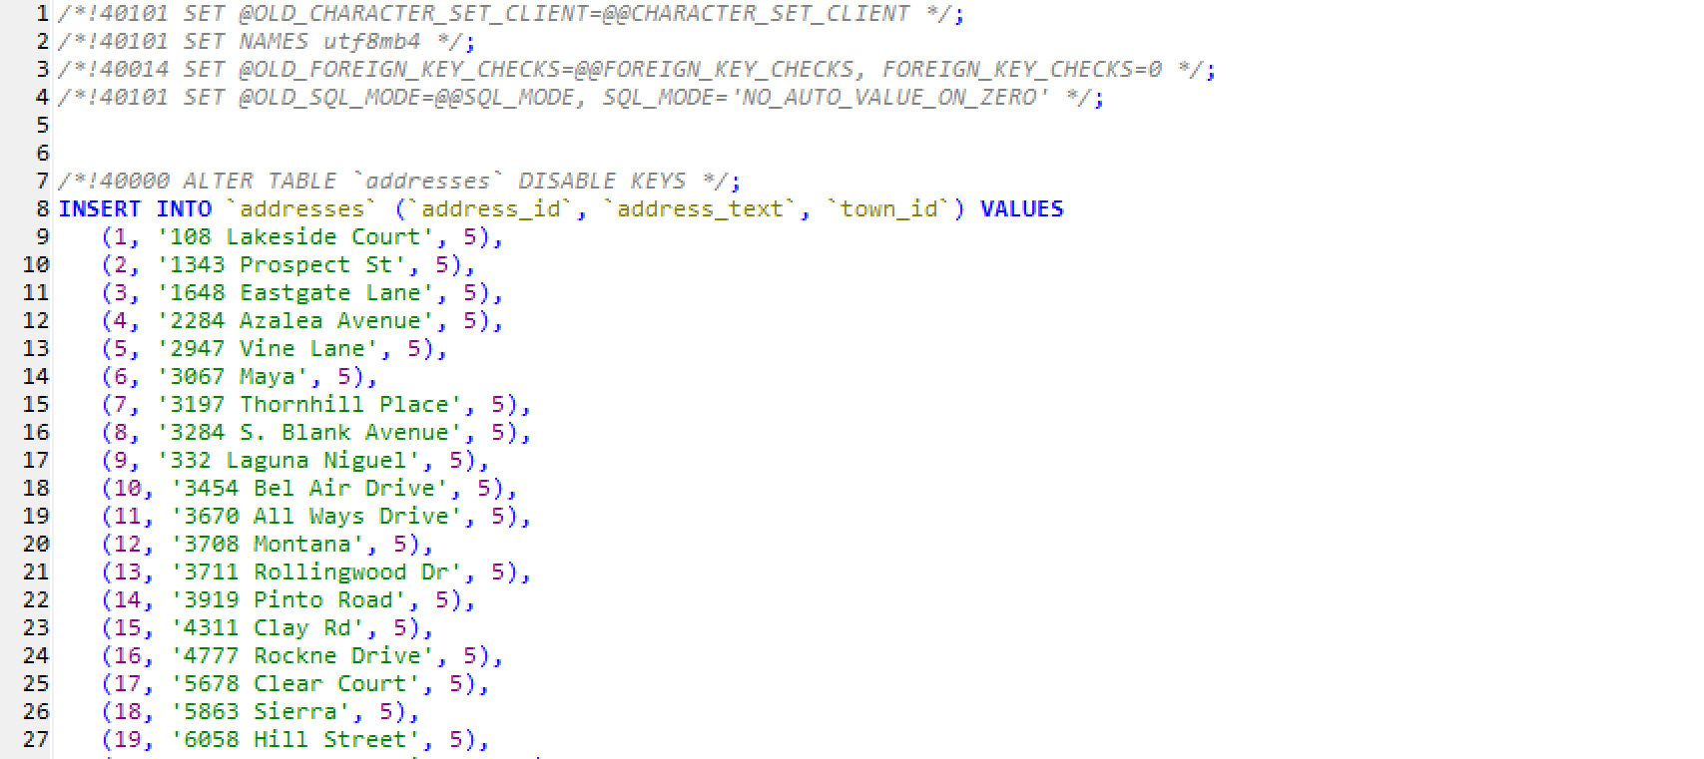

## Create Objects

Use the **soft_uni database**. Create new **Department Training**. Create new **Town Burgas**. Create **several new addresses** that would be **in Burgas**. Create **5 employees** and **assign them in the Training department** and make their addresses to be some of the addresses in Burgas. Make sure they are **all persisted** in the database.

## Remove Objects

Use **soft_uni** database. Persist **all towns** from the database. Detach those whose name length is **more than 5 symbols**. Then transform the **name** of all attached towns **to lowercase** and **save them to the database**.

## Contains Employee

Use **soft_uni** database. Write a program that check if given employee name as an input **is contained in the database.**

### Example

|  |  |
| --- | --- |
| **Input** | **Output** |
| Svetlin Nakov | Yes |
| John Doe | No |

## Data Refresh

Use **soft_uni** database. Get employee with id 4. Transform his first name to be uppercase. Then refresh the entity manager and persist that employee. Now print the first name of the employee. Was the uppercase transform successful?

## Employee Queries

### Step 1 - Employees with Salary Over 50 000

Let's start writing queries! Your first task is to extract **all employees** with **salary** over **50000**. Make sure the query returns **only the** **first names** of those employees.

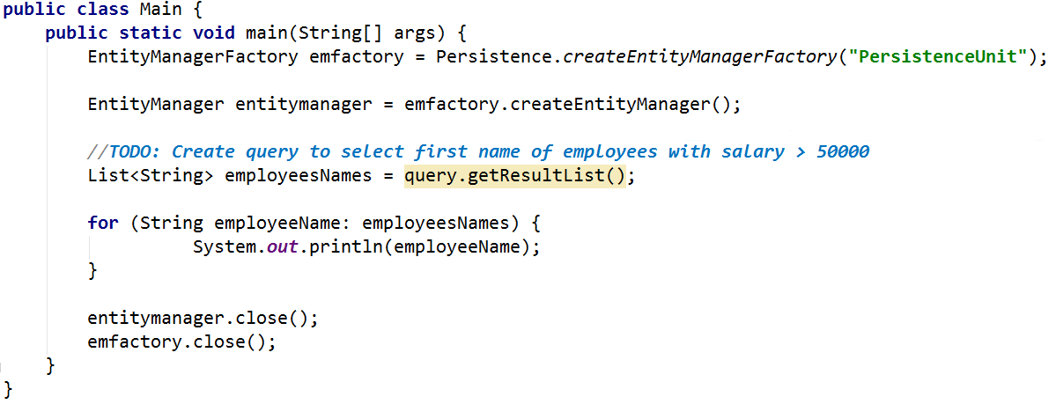

Result on console:

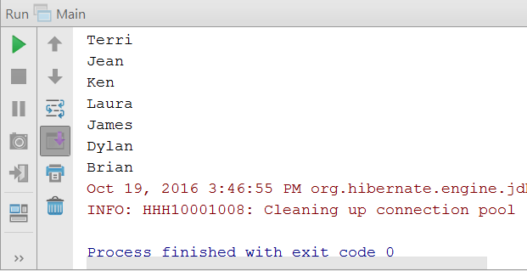

### Step 2 - Employees from Seattle

Extract all employees from the **Research and Development** department. Order them by **salary** (in ascending order), then by **first name** (in descending order). Print only their **first name**, **last name**, **department name** and **salary**.

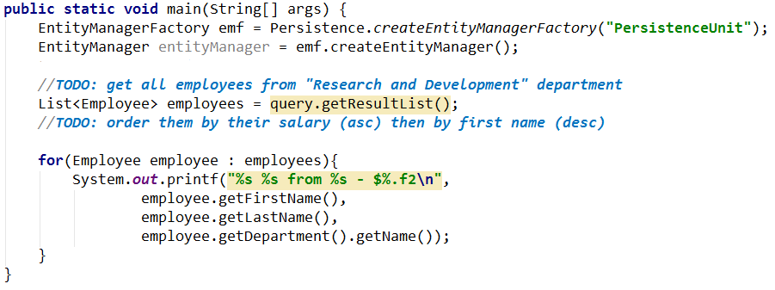

Result on console:

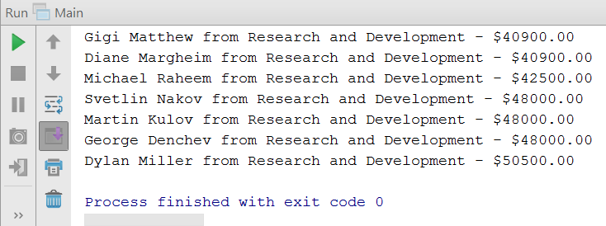

## Adding a New Address and Updating Employee

Create a new address with **text** "**Vitoshka 15**". Set that address to the employee with last name “Nakov”

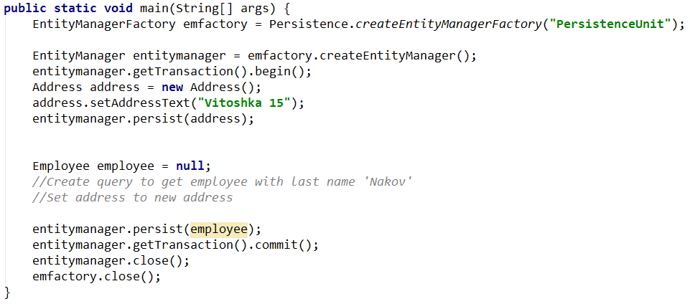

The above code should successfully **insert a new address** in the database and **set it as Nakov's new address**.

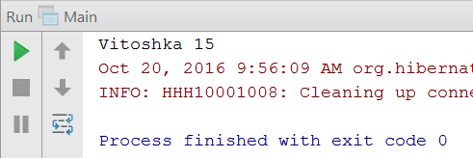

## Database Search Queries

Write the following queries:

1. Find all addresses, **ordered** by the **number of employees** who live there (descending), then by **town name** (ascending). Take only the **first 10 addresses** and print their **address text**, **town name** and **employee count**.

|  |  |
| --- | --- |
| **Query Materialization** | **Example Query Result** |
|  | 163 Nishava Str, ent A, apt. 1, Sofia - 3 employees  7726 Driftwood Drive, Monroe - 2 employees  7902 Grammercy Lane, Bellevue - 1 employees  5678 Clear Court, Bellevue - 1 employees  2284 Azalea Avenue, Bellevue - 1 employees  9745 Bonita Ct., Bellevue - 1 employees  6448 Castle Court, Bellevue - 1 employees  3454 Bel Air Drive, Bellevue - 1 employees  7808 Brown St., Bellevue - 1 employees  4777 Rockne Drive, Bellevue - 1 employees |

1. Get an **employee by id** (e.g. 147). Print only his/her **first name**, **last name**, **job title** and **projects** (only their names). The projects should be **ordered** **by** **name** (ascending).
2. Find all employees who have **projects** started in the time period **2001 - 2003** (inclusive). Print each employee's **first name**, **last name** and **manager name** and each of their projects' **name**, **start date**, **end date**.
3. Find **all departments** with more than **5 employees**. Order them by **employee count** (ascending). Print the **department name**, **manager name** and first name, last name, hire date and job title of every **employee**.

|  |
| --- |
| **Query Materialization** |
|  |
| **Query Result** |
| 13  --Engineering - Manager: Duffy, Employees: 6  --Production Control - Manager: Krebs, Employees: 6  --Human Resources - Manager: Barreto de Mattos, Employees: 6  --Shipping and Receiving - Manager: Ackerman, Employees: 6  --Research and Development - Manager: Trenary, Employees: 7  --Quality Assurance - Manager: Word, Employees: 7  --Facilities and Maintenance - Manager: Altman, Employees: 7  --Marketing - Manager: Harnpadoungsataya, Employees: 8  --Finance - Manager: Tamburello, Employees: 10  --Information Services - Manager: Trenary, Employees: 10  --Purchasing - Manager: Bradley, Employees: 12  --Sales - Manager: Welcker, Employees: 18  --Production - Manager: Hamilton, Employees: 179 |

## Concurrent Database Changes with Entity Manager

Open two different entity managers and perform concurrent changes on the **same records** in some database table.

1. Begin transaction in the first entity manager and make changes to a column
2. Begin transaction the second entity manager and make changes to a column
3. Consecutively call **getTransaction().commit()** on both entity managers

What will happen at getTransaction().commit()?

Change the **locking mode** of the objects to **pessimistic**. Run the code again and see if there are any differences.

## Find Latest 10 Projects

Write a program that prints **last 10 started projects**. Print **their name, description, start and end date** and **sort** **them by name** lexicographically.

### Output

|  |  |  |  |
| --- | --- | --- | --- |
| **Name** | **Description** | **Start Date** | **End Date** |
| All-Purpose Bike Stand | Research, design and developm… | 2005/09/01 | (NULL) |
| Bike Wash | Research, design and developm… | 2005/08/01 | (NULL) |
| HL Touring Frame | Research, design and developm… | 2005/05/16 | (NULL) |
| … | … | … | … |

## Increase Salaries

Write a program that increase salaries of all employees that are in the **Engineering**, **Tool Design**, **Marketing** or **Information Services** department by **12%**. Then **print first name, last name and salary** for those employees whose salary was increased.

### Example

|  |
| --- |
| **Output** |
| Kevin Brown ($15120.00)  Roberto Tamburello ($48496.00)  Rob Walters ($33376.00)  … |

## Remove Towns

Write a program that **deletes town** which name is given as an input. Also **delete all addresses** that are in those towns. Print on the console the number addresses that were deleted.

### Example

|  |  |
| --- | --- |
| **Input** | **Output** |
| Sofia | 1 address in Sofia was deleted |
| Seattle | 44 addresses in Seattle were deleted |

## Find Employees by First Name

Write a program that finds all employees whose first name starts with pattern given as an input from the console. Print their first, last name, their job title and salary in the format given in the examples below.

### Example

|  |  |
| --- | --- |
| **Input** | **Output** |
| SA | Sariya Harnpadoungsataya - Marketing Specialist - ($14400.00)  Sandra Reategui Alayo - Production Technician - ($9500.00)  Sairaj Uddin - Scheduling Assistant - ($16000.00)  Samantha Smith - Production Technician - ($14000.00)  Sameer Tejani - Production Technician - ($11000.00)  Sandeep Kaliyath - Production Technician - ($15000.00) |

## Employees Maximum Salaries

Write a program to find the **max salary** for each **department**. Filter those which have max salaries not in the range 30000 and 70000.

### Example

|  |
| --- |
| **Output** |
| Tool Design - 29800.00 |